# Day 1 - Password Policy GPO

**Open Group Policy Management**
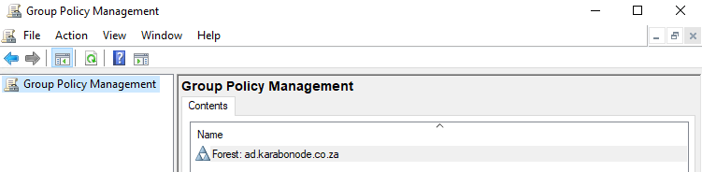
**Navigate to the Default Domain Policy:**
**Set the password policy:**
```
Computer Configuration > Policies > Windows Settings > Security Settings > Account Policies > Password Policy
```
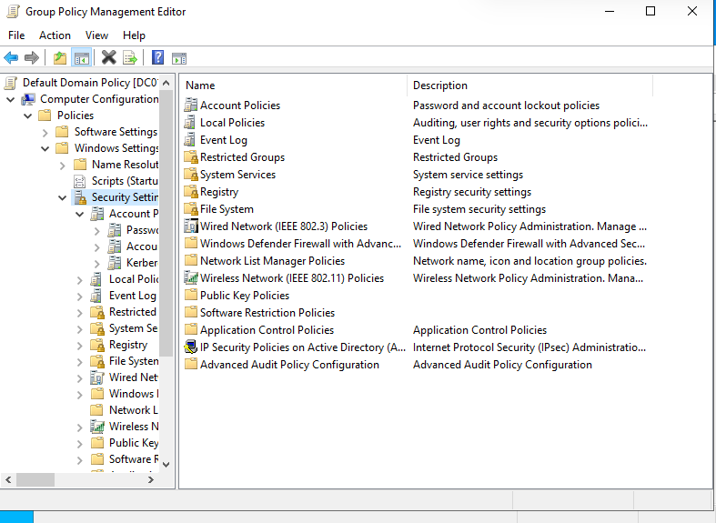
Before Changes
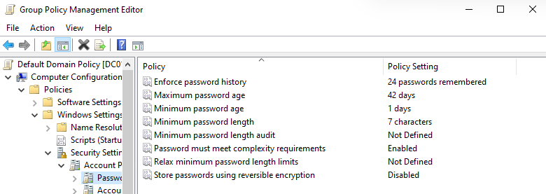
After Changes
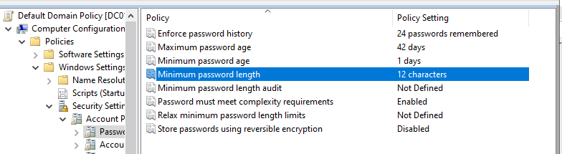
**Set the lockout policy**
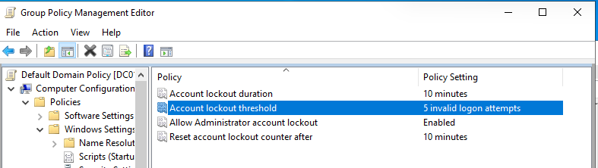
**Apply and verify.**
gpupdate /force
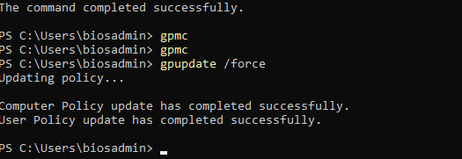
Gpresult -r
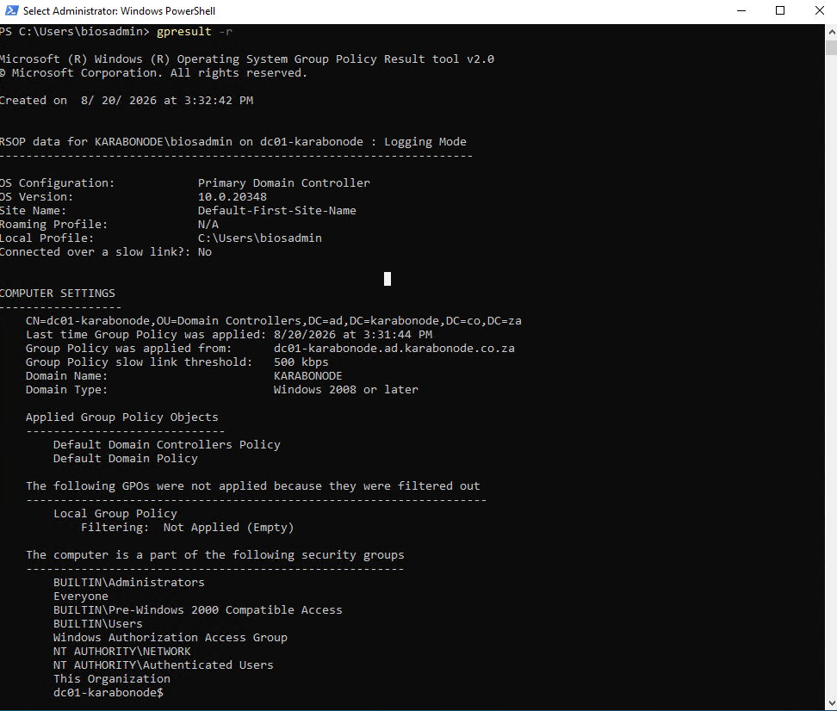

## Why this matters
Named directly in real SOC/Admin postings as baseline hardening.

## Skills covered
GPMC navigation, Default Domain Policy password/lockout configuration, `gpupdate`/`gpresult` verification workflow.

